
SEA2004 F Class Test - Thursday 17th March 2011
Complete all 2 sections – all questions carry 5 marks
Test weighting 12.5% of overall course mark

Module 1 - Ocean Bathymetry and Water Properties – Dr I.J. Ansorge
(1) The map below represents the bathymetry in the South-east Atlantic Ocean. Lines represent isobaths with the following dashed black, shaded = 5000m, solid black, shaded = 3000m, dotted black = 2000m, solid black = 1000m and shaded = 250 m. Label onto the map the positions of the following: continental shelf, abyssal plain, continental slope, mid ocean ridge, horizontal transform fault.
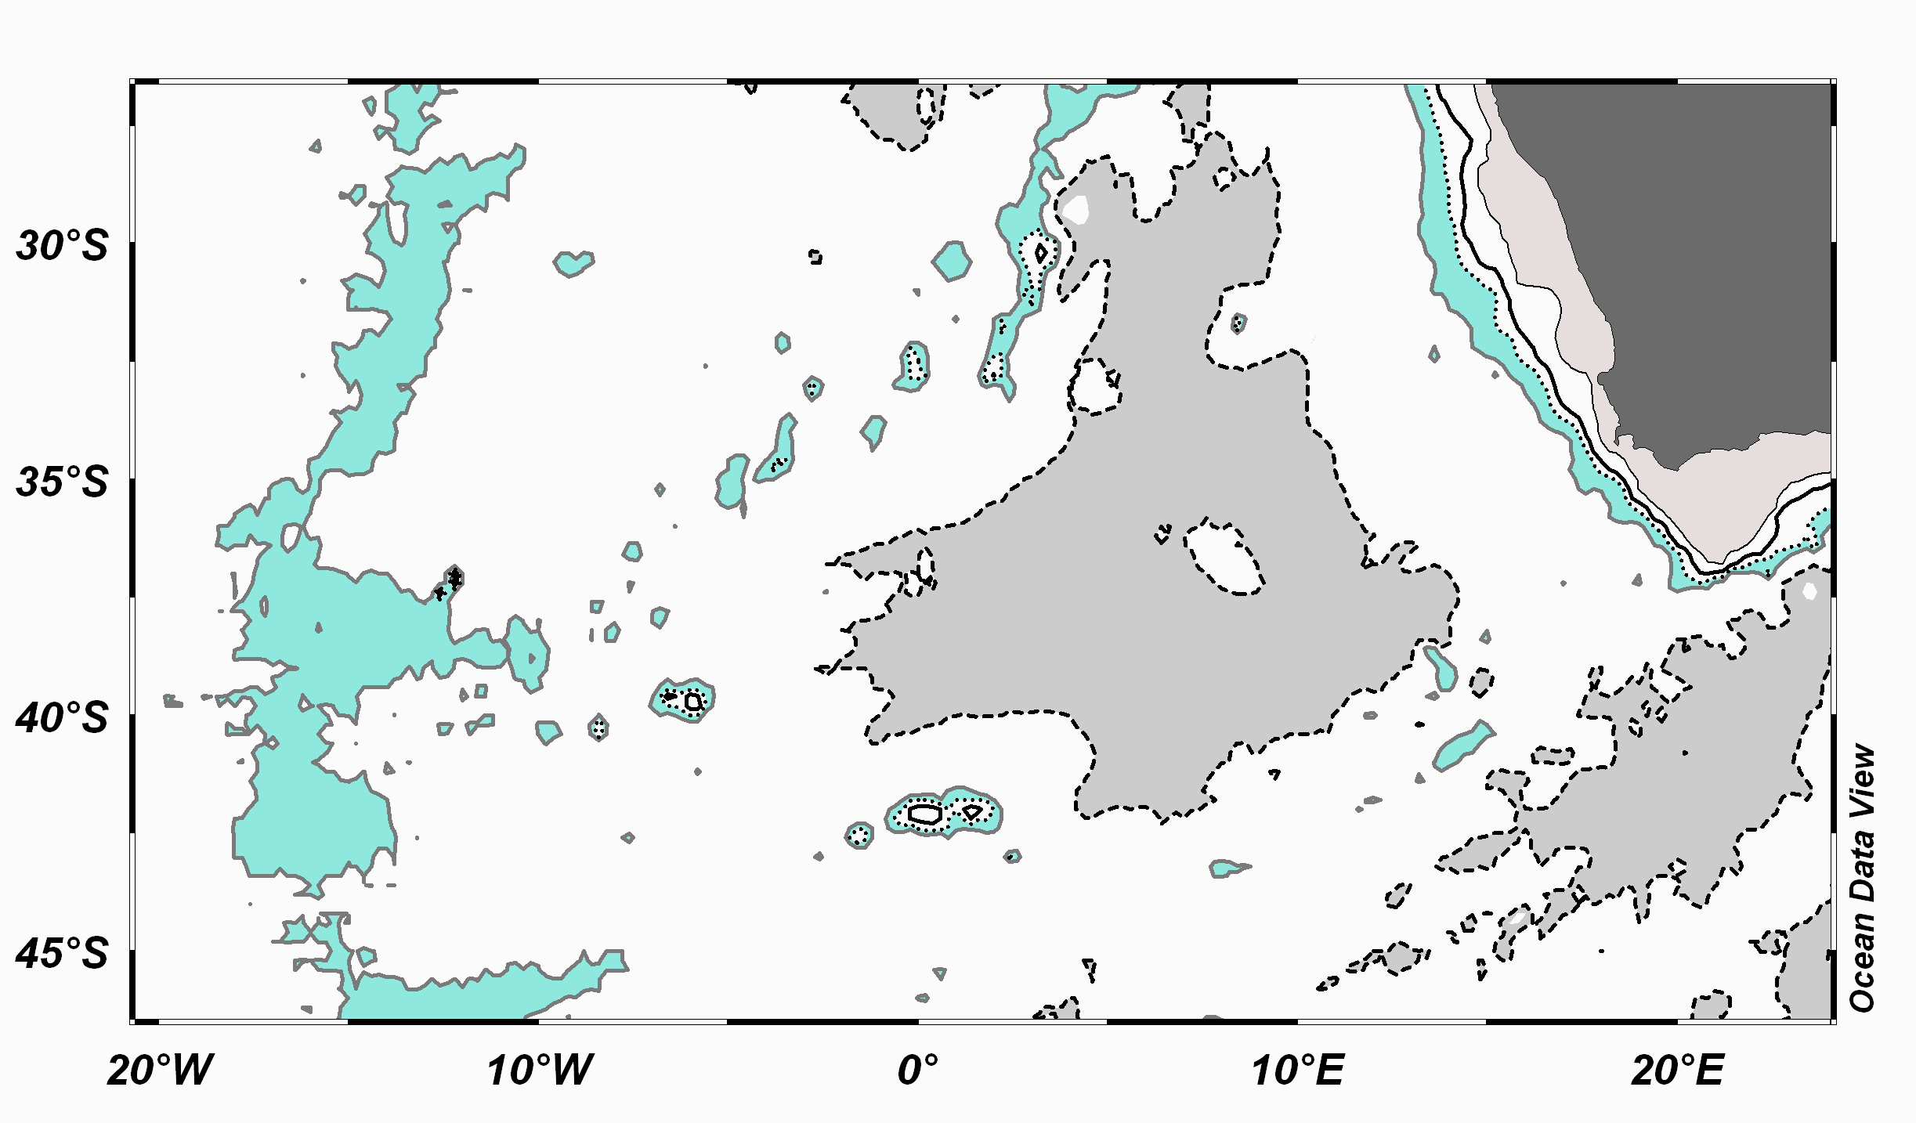

(2) Calculate the rate of spreading in the Atlantic Ocean – when the time of the polarity change was 50,000 years ago and the distance to the mid ocean crest is 250 m. What spreading rate would you need to increase your distance by an additional 150 m (i.e. a total of 400 m) for the same period?
(3) List the 6 most important ions in seawater. Which ion has the highest concentration in seawater?
(4 a) What is the sigma t (σt) value when density is 1026kgm⁻³?
(4 b) Using the TS plot below provide the following values for A, B and C:
(T = Temperature, S = Salinity)
when A = T 20°C, σt = 26 – what is the salinity?
when B = S 35.5, T 15°C – what is density (caution! not σt)
when C = a mix of A and B

(5) Using the hydrostatic equation calculate the depth in metres for the following pressures at σt 25: 250 db, 3000 db and 50 db. The hydrostatic equation P = ρgh where P = pressure, g = gravity 9.8 m/sec², h = height and ρ = density kgm⁻³. NB: 1 db = 10⁴Pa

